eRS Update for Urgent Triage Services
  - EMIS Web
17th April 2024

Contents
1 eRS Triage Updates 3
2 Changes to the Service Selection Screen 4
2.1 Old process 4
2.2 New process 5
3 What do you do if triage referrals have been processed incorrectly? 7

eRS Triage Updates
In March 2024 there were several changes in referring patients to Triage/Referral Assessment Service’s (RAS) in eRS.
Previously if you wished to send a patient to a Triage/RAS you could only select the one service using the blue ‘Send for Triage’ button. This is no longer an option on the service selection screen.
This is because referrers are now able to create a shortlist of services for patients to choose from, which include any combination of Triage/RAS and bookable services. This supports patient choice.
It may be clinically appropriate in the following circumstances to continue to refer to a specific Triage/RAS: -
- If the patient needs support in making the appropriate choice or if the patient has specified their choice.
- 2WW’s - If the patient is being referred on an urgent suspected cancer pathway.
The process for referring to a specific Triage/RAS has now changed slightly.
The purpose of this guide is to update on the new process for referring to a specific triage service and what to do if the old process has been followed in error. As an example, if a 2WW triage service has been selected and then ‘Requested’ (old process) the patients will need to be identified in the eRS portal worklists and then redirected to the appropriate triage service using ‘Book/Send for Triage’ (new process).
The information in this guide contains dummy patient information in a test eRS environment.

Changes to the Service Selection Screen

Old process
- When presented with the Service Selection screen
- The triage service would be selected using the ‘Send for Triage’ button.
- Continue through to Submit the referral.
- Print/email the patient their letter.
The letter would correctly state that the patient has been placed on the awaiting triage list of the provider and will be contacted.

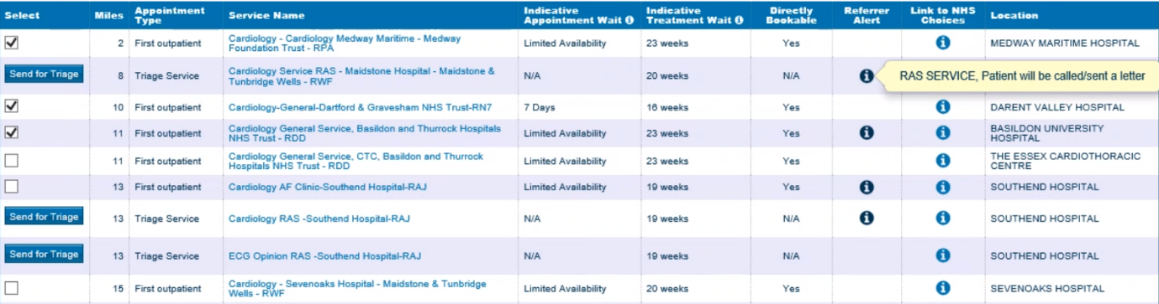

Since the changes, the send for triage button is now a tick box and if the Request button is selected to process the triage, the patient is NOT placed on the awaiting triage list of the provider.
The letter to the patient will state that the patient must contact the provider as per the example below: -
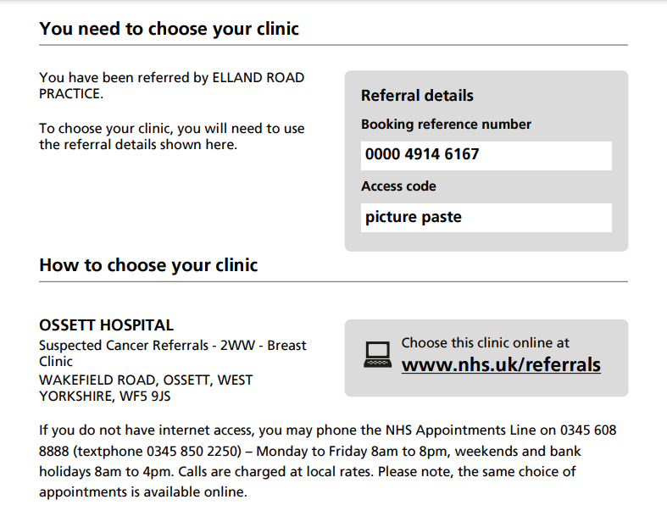

This is not the correct process as the patient needs to be put on the awaiting triage list immediately.

New process
- When presented with the Service Selection screen
- The triage service is selected using a tick box.
- Once ticked you need to select Book/Send for Triage (which has replaced the Appointment Search button).

- This takes you to the Book/Send Triage screen.
- Select the ‘Send for Triage’ button which has moved here for your required service.

- Continue to Submit the referral.
- Print/email the patient their letter.
The letter will correctly state that the patient has been placed on the awaiting triage list of the provider and will be contacted.
The patient IS placed on the awaiting triage list of the provider.
The letter to the patient reflects the patient is on the awaiting triage list and will be contacted as per the example below: -
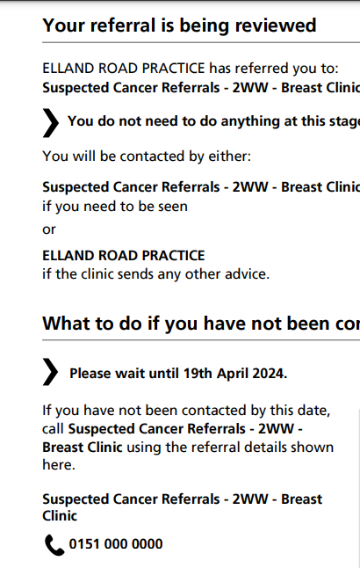

Please click on the following link to a short video demonstrating the new process.
eRS Send For Triage Update Video April 2024

What do you do if triage referrals have been processed incorrectly?
Whilst every effort has been made to update surgeries ahead of these changes by NHS England there may be occasions where the old process has been followed and urgent triages are not sent to the appropriate service providers awaiting triage list.
The referrals will need to be checked in the eRS portal and redirected as appropriate.
- Navigate to the eRS portal.
- Select Worklist Tab.
- Select Awaiting Booking Tile on the dashboard and it will list the patients awaiting booking or triage.
- Sort by the priority column header for 2 Week Waits first.
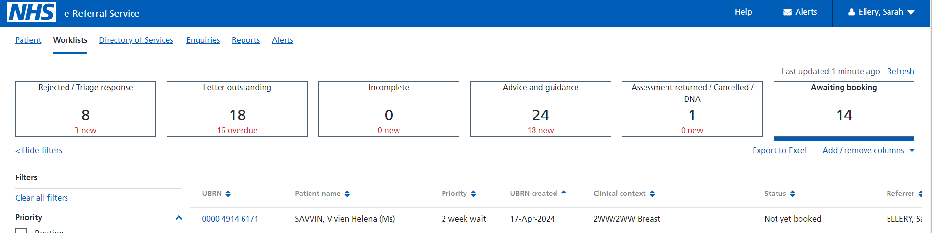

- Select the UBRN of the patient you wish to re-refer correctly. In the example above our patient has been booked following the old process of request and the status is not yet booked.
- Once the UBRN is selected the Referral Summary Page is opened.
- Select the Actions button.
- Select Book/Send for Triage.
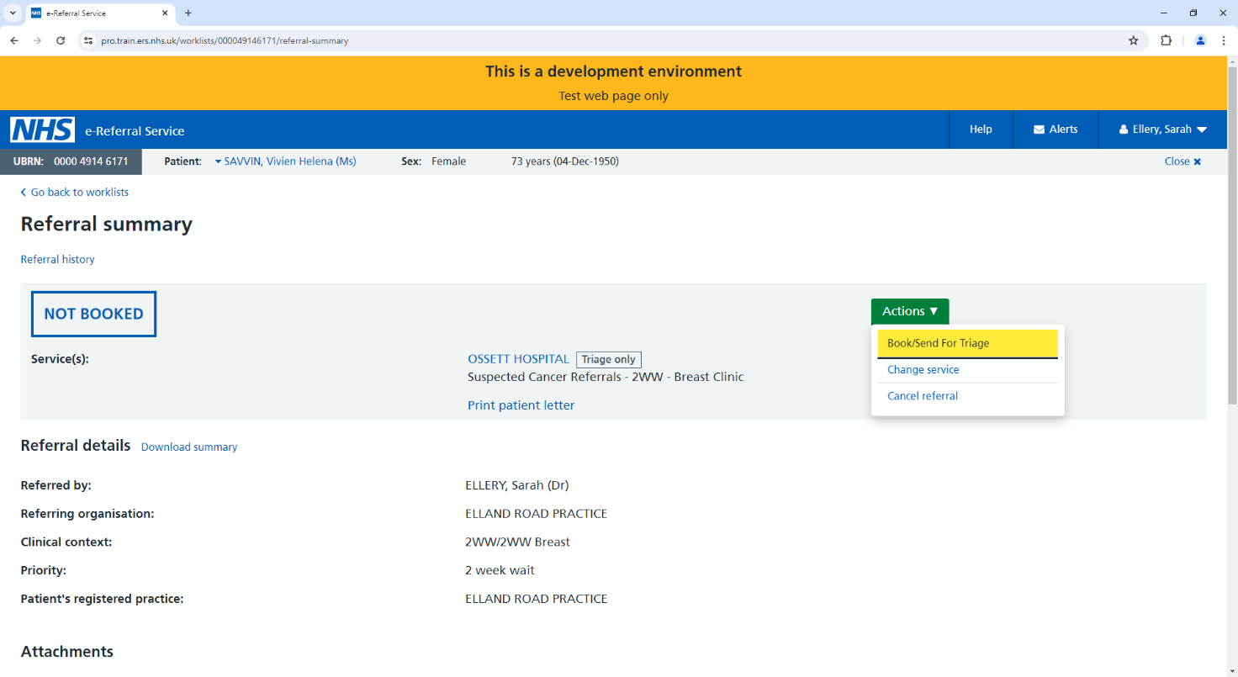

- The Book/Send for Triage screen will open.
- Select Send for Triage button.

- Select Submit

- Print/email as required.
- Select Close

- On the Awaiting Booking worklist, you will now see that the referral status is correctly awaiting triage.
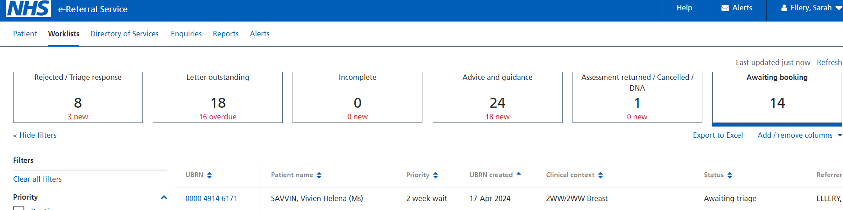

VERSION CONTROL

Document Title | Document Type | Version | Date | Source
eRS Update for urgent Triage Services Guide | Guide | V1.0 | 17/04/2024 | Guide

CHANGE CONTROL

Document Title | Version | Date | Author | Change | Purpose | Approved
eRS Update for urgent Triage Services Guide | V1.1 | 17/04/24 | KR | Creation of guide draft | eRS urgent update

