Guidance and Standard Operating Procedures
Kent and Medway
COVID-19
Primary Care Assessment & Treatment facilities/general practice sites

FINAL updated 13/04/20

Status | Approved
Version number | 1.4
Replacing/Superseded policy or documents | 1.3
Number of pages | 29
Target audience/applicable to | Primary Care
Author | Primary Care Cell
Contact point for queries | wkccg.gpscovid19@nhs.net
Date ratified | 13 April 2020
Date of implementation/distribution | 09 April 2020
Circulation | Primary Care
Review date | Ongoing
Copyright | NHS Kent and Medway CCG

Version | Revision
1.0 | NA
1.1 | Amended links
1.2 | - Appendix 3 - revised  - Medicines management service spec – new  - Inclusion of Algorithm for NHS 111, COVID-19 Clinical Assessment Service and GP Interface  - CCAS pathway - revised  - Links – amended  - Clarification of remote assessment of patients with symptoms of COVID-19 (4.2)
1.3 | - Appendix 3 – revised
1.4 | - Hot and cold site terminology revised

Introduction

This standard operating procedure and guidance document has been produced in response to the COVID 19 pandemic. The document sets out the methodology that we will use to ensure that contact between patients requiring primary care with COVID-19 symptoms, (including those who reside with others that have these symptoms), and those without COVID-19 symptoms is minimized, in order to reduce cross-contamination and spread. Adherence to this procedure and guidance document will ensure that patients’ needs are met and that primary care is arranged in the most efficient, effective and safe an environment as is possible during this period for the benefit of both patients and staff. This guidance applies to all children and adults in need of primary care irrespective of COVID 19 presentation.

This operating procedure applies to all Kent and Medway PCNs & practices and is informed by the NHSI COVID-19 Primary Care SOP GP practices.

The model includes primary care support for patients that are confined to their own homes including nursing and care homes and residential facilities for people with learning disabilities.

Facilities that are designated to assess and treat possible COVID-19 patients (patients that have or assessed as may have COVID 19) face to face will be known as “primary care treatment centres” (formerly “hot sites”). Facilities that are designated to assess and treat patients where neither they nor members of their household have symptoms of COVID19 will be known as “general practice sites” (formerly “cold sites”). For consistency and continuity during this period all sites providing primary care assessment, triage and treatment during this period will either be referred to as primary care treatment centres or general practice sites.

1.2 Case definition and household guidance
Public Health England (PHE) has updated its possible COVID-19 case definition, guidance on testing and on which cases should be reported to local health protection teams.
The government has published stay at home guidance for households where a household member meets the possible case definition.
This guidance is correct at the time of publishing. However, as it is subject to updates, hyperlinks must be used to confirm the information therein.

Scope
This guidance is applicable in all Kent and Medway PCNs and practices.
How this guidance is delivered will vary between PCN areas and practices. Local arrangements will be shared and updated.
The collaborative endeavours of the primary care workforce in delivering the national strategy on COVID-19 are an essential element of the NHS measures and our local response.
We recognise the impact that the COVID-19 response is having and will continue to have on our staff, and we are deeply grateful for their dedication and care.

COVID-19: Standard operating procedure (SOP) for Kent and Medway PCNs and practices

3.1 Key principles
All practice staff must be made aware of this SOP, the current guidance and the possible COVID-19 case definition.
Remote consultations will be used wherever possible to minimise risk of transmission.
Infection prevention and control measures must be applied when seeing patients for face-to-face consultations. These measures may vary between primary care treatment centres and general practice sites; the latest guidance will be followed.
The following document must be used to determine which sites patients must be referred to where it is identified that face to face consultation is clinically necessary.

3.2 New ways of working
Collaboration between practices within primary care networks (PCNs and practices) and with community services will be required as pressure on the health system escalates. Collaboration will vary from area to area. These arrangements will ensure that we are able to deliver the best community based care for our patients and best protect and maximise the capabilities of staff across the practices. National guidance can be found here.
Practice communications (website, telephone, SMS) must direct patients to the latest guidance. Practices across the network will display messages on their website that reflects NHS guidance.
To mitigate any risk of potentially infected patients booking appointments online and attending the practice when they must be receiving advice to stay at home or go through testing, all practices within the PCN will suspend on line booking.

Remote triage and consultation

4.1 Algorithm for NHS 111, COVID-19 Clinical Assessment Service and GP Interface

The following algorithm will be used to determine assessment is as follows:

Cohort 1: Patient demonstrating severe symptoms, requires treatment in hospital and will likely require an ambulance response.

Cohort 2: Symptomatic patients requiring further clinical assessment before final disposition is decided, this will include all shielded patients. (these are referred to the COVID Clinical Assessment Service or CCAS).

Cohort 3: Patient is showing mild symptoms and advised to self-isolate at home and to reassess via NHS 111 (online whenever possible) if symptoms deteriorate (GP informed via a post event message).

CCAS: An NHS 111 service staffed remotely by experienced retired GPs.
Post event message: A tool for NHS 111 to inform GP that a clinical assessment for COVID-19 has taken place.

4.2 Remote assessment of patients with symptoms of COVID-19

- Patients with symptoms of COVID-19:
* will be directed to NHS 111 (online, telephone if necessary) in the first instance.
* may make direct contact with general practice or be referred by NHS 111/the COVID-19 Clinical Assessment Service (CCAS).
* Avoid redirecting patients to NHS 111 if they present to general practice either because they cannot get through to NHS 111 online/by telephone, or because an NHS 111 clinician has directed them to their GP: the risk of patients becoming stuck in a loop between NHS 111 and general practice poses significant risk to unwell patients.
- Guidance on remote assessment of patients with symptoms of COVID-19 can be found on the BMJ website.
- Guidance on diagnosis, assessment and management of COVID-19 pneumonia in the community can be found on the NICE website.
- In deteriorating patients with symptoms of COVID-19, clinicians should be alert to potential alternative diagnoses.

The charts below illustrate the clinical pathways for remote triage and consultation.

NHS 111 and CCAS pathway

- General practice site facility requirements and guidance
The definition of a ‘general practice site’ is: There is a low probability of presentation of Covid-19.
General practice sites are designated general practice surgeries. General practice sites will operate within core general practice hours.
Access to appointments at general practice sites will be determined following remote triage and assessment.
Shielded patients that have been triaged and assessed as non COVID-19 and require a face to face consultation will where possible been seen at a general practice site.
Staffing and capacity required for general practice sites will be determined at a local level. Separate guidance for the management and facilities recommended for general practice sites will be published.

Home visits including nursing and care homes including residential facilities for people with learning disabilities
Remote triage for possible COVID-19 will take place before a home visit is arranged.
Where possible consultations should be undertaken remotely rather than via a home visit,
Patients assessed as needing a face to face home visit will include COVID -19 and non COVID-19 patients as illustrated in the clinical flow charts in section 4.
Home visits will be required for patients that meet the pathway criteria for primary care treatment centres but do not have access to private transport or are unable to walk to the designated primary care treatment centre.
Healthcare staff performing non-deferrable essential visits to households with possible COVID-19 must follow the infection control measures as outlined here, including use of personal protective equipment (PPE).
Healthcare staff should be allocated to either provide either COVID or NON COVID care on the same shift.

It is recommended that all shielded patients requiring face to face care receive a home visit.
All shielded patients that have been triaged as COVID-19 or possible COVID 19 and require a face to face visit criteria will receive a home visit.
Where possible a separate home visiting service for COVID- 19 shielded patients will be provided.
If the patient needs emergency medical care in hospital, an ambulance should be requested where appropriate, and the 999 call handler informed of COVID-19 risk. If the patient requires emergency care while awaiting ambulance transfer, the healthcare professional must use PPE and keep exposure to a minimum.
Careful handwashing must be observed before and after home visits.
‘Home visit’ wipeable boxes containing all necessary additional PPE and clinical waste bags must be used.

Primary care treatment centre Facilities and guidance
The definition of a ‘primary care treatment centre’ is: There is a high probability of presentation of patients with COVID -19 symptoms that need a face to face review following senior clinical telephone triage aspects
Access to appointments at primary care treatment centres will be determined following remote triage and assessment process as set out in section 4.
Screening and triage will not take place at primary care treatment centres.
Primary care treatment centres must be registered with CQC. Guidance about registration can be found here.

The core hours of primary care treatment centres are 10am to 6pm Monday to Friday.

It is recommended that staff will work shifts of no more than 4 hours and no more than two shifts per week.

The current assumed required capacity for primary care treatment centres at the peak of the pandemic is between 120 – 150 new patients per day per 60,000 population. This figure is subject to change.

Appointments should be a minimum of 30 minutes long to allow sufficient time for decontamination between patients.

A summary of the attributes of primary care treatment centres in included in Appendix

7.1 Primary care treatment centre management
Each site will have an appointed lead to ensure that the site is prepared and managed as set out in this guidance. These arrangements will be agreed at a local level. There should be regular contact at PCN level to ensure that staffing and site management issues are discussed.
This information should be collated and cascaded to all Lead Clinicians.

7.2 Preparation of primary care treatment centre accommodation
All sites must be prepared as follows:
- It is recommended that all sites meet the attributes set out in section 7.1
- All staff must be briefed on the use of the rooms/areas and actions required in the event that it is necessary to vacate rooms/areas at short notice.
- Appropriate signage directing and providing guidance to patients must be displayed.
- Patient ‘support packs’ must be prepared for all patients. This may include items such as bottled water, disposable tissues, clinical waste bag and fluid- resistant surgical mask.

7.3 Primary care treatment centre arrangements

7.3.1 On arrival
Patient information posters for NHS settings are displayed where they can be seen before patients enter the premises.
All primary care treatment centres will operate a locked access policy.
Primary care treatment centres must be secure. Equipment and facilities including drugs required to provide urgent care for patients that are likely to be referred to the site must be kept securely on site. A list of likely equipment, facilities and drugs will be developed.
Infection control standards in line with current guidance must be met.
Primary care treatment centres must have safe storage facilities for staff member’s personal effects and access to facilities and equipment they need to work safely. This includes but is not limited to PPE and washing and changing facilities.
Only patients that have been triaged and given an appointment will be allowed onto the primary care treatment centre.
Patients that have not been triaged and do not have a booked appointment will be redirected to contact NHS 111 or their local practice.
Following consultation patients will be advised of the follow up arrangements that they should make. Where patients are vulnerable this may include a follow up by the patient’s usual practice.

Infection Control

Current guidance relating to primary care treatment centres is included as Appendix 3. This guidance is subject to regular update. The links annotated below should be used to ensure that practice adheres to current guidance. Robust infection control arrangements are essential for the safety of patients and staff.

8.1 Personal protective equipment
Please see here for the latest guidance on PPE. This guidance varies between primary care treatment centres and general practice sites and for home visits.
All staff must be trained in the proper use of all PPE that they may be required to wear.

8.2 Decontamination
Cleaning and decontamination must be carried out in line with the government guidance here.
All patient consultation areas must be decontaminated after each patient.

9. Medicines Management

9.1Prescribing process and delivery of medication

9.1.1 Prescribing
All prescribing should be in line with the local Integrated Care Provider formulary and national guidance, where applicable.

All items should be prescribed via EPS where possible, and sent to pharmacy that is aligned to Primary care treatment centre.

All items prescribed must be written generically, unless where a drug needs to be prescribed by brand for clinical reasons (for example aminophylline)

Prescribing for COVID-19 potential patients. Detailed guidance is being developed.

9.1.2 Pharmacy Delivery/Collection

Patients and staff who have been to a primary care treatment centre MUST NOT attend the co-located community pharmacy or dispensary. This is for the safety and protection of the other patients visiting the pharmacy and also for the staff of the pharmacy’

At the time of prescribing the prescriber must consider the options for the patient in the following order:
- Is there anyone who can collect the prescription on behalf of the patient (Friends/ neighbour or family who does not reside with patient)?
- If the prescription is sent to the pharmacy can it be collected on behalf of the patient (voluntary sector, friends/family)
- If no to both the above then prescription should be scanned and emailed to pharmacy or (preferably) sent via EPS (the nominated pharmacy may need changing at this point) as per the process below:

9.2 Emergency medication

Primary care treatment centres should consider where a patient presenting with an emergency condition would be managed and ensure that this place would be appropriate. Drugs should be held in the primary care treatment centre to help manage medical emergencies.

A suggested list of emergency medicines to be kept at primary care treatment centres (consistent with the requirement for GP Practices) can be found at https://www.cqc.org.uk/guidance-providers/gps/nigels-surgery-9-emergency-medicines-gp-practices

9.3 Oxygen Provision

All Primary care treatment centres must be equipped to deal with a medical emergency and all staff should be suitably trained. Further guidance will follow.

The Resuscitation Council (UK) lists minimum suggested equipment to support CPR in primary care settings. https://www.resus.org.uk/quality-standards/primary-care-equipment-and-drug-lists/#equipment

Guidance for staff
We recognise the pressures and anxieties that frontline staff face in response to the coronavirus pandemic. A national letter was published supporting doctors and healthcare professionals in the coronavirus pandemic.
Major regulators have issued guidance to support healthcare professionals in these challenging circumstances, encouraging partnership working, flexibility and operating in line with the best available guidance.

10.2 Staff meeting possible case definition
Staff that meet the possible COVID-19 case definition should stay at home as per advice for the public. Staff who are well enough to continue working from home should be supported to work from home.

10.3 Staff Morale

It is vital that staff morale is upheld during this time of great anxiety for the staff.
Everyone in the practice has a responsibility to make all staff;

- Feel safe
- Feel supported,
- Feel part of the team,
- Feel they are making a difference for the safety of our community.
To do this, staff engagement and communication are vital.

10.4 Guidance for staff at increased risk from COVID-19
The government has issued guidance about social distancing and shielding for vulnerable groups at particular risk of severe complications from COVID-19. Staff that fall into these categories should not see any patients face-to-face, regardless of whether a patient has possible COVID-19 or not. Remote working should be prioritised for these staff.

10.5 Staffing policy at sites
Safe staffing levels will be determined at a local level. Workforce sharing agreements will be put in place to share clinical staff.
Any concerns about safe staffing levels should be reported to the PCN and Primary Care Cell.
All staff should be risk assessed on an ongoing basis to protect them. Advice on self certification can be found here.

11. Information Governance
All data sharing should follow Covid-19 – Notice under Regulation 3(4) of the Health Service Control of Patient Information Regulations 2002.

12. Communication and information from NHSE and other bodies.
- At urgent times of need: Central Alerting System:
For urgent patient safety communications, NHSE will contact practices through the Central Alerting System (CAS).
All practices must registered to receive CAS alerts directly from the Medicines and Healthcare products Regulatory Agency (MHRA)
- At less urgent times: commissioner’s cascade:
For less urgent COVID19 communications, NHSE will email through local commissioners.
- Supportive additional information:
NHSE will use a variety of different additional methods to keep practices informed of the emerging situation, alongside Royal Colleges, regulators and professional bodies, through formal and informal networks, including social and wider media.
These Twitter accounts can be followed to keep up to date:
NHSEnglandandNHSImprovement:@NHSEngland
The Department for Health and Social Care @DHSC
Public Health England @PHE_uk.
Bookmark and regularly review the hyperlinks to official guidance from PHE and NHS England and NHS Improvement to ensure up-to-date knowledge and any changes to protocols. Information for primary care has been collated here.
- For COVID-19 related questions and issues, email
- Royal College of General Practitioner’s guidance can be found here
- British medical Journal guidance can be found here
- Guidance on caring for vulnerable patients
- Hospital discharge guidance and leaflets
- For sick notes, Patients should click onto following website: https://www.nhs.uk/conditions/coronavirus-covid-19/self-isolation-advice
- National Database of Information related to COVID-19

Appendix 1

Guidance for Primary Care Primary care treatment centre COVID Assessment
and Escalation

Initial assessment

The following information should be gathered either at home or in a Primary care treatment centre, whilst wearing recommended personal protective equipment and following standard operating protocols:

- History
- Categorisation of risk: age, co-morbidities, immune-suppressed (see below for classification guidance)
- Pulse, temperature
- BP
- Oxygen saturation
- New onset confusion
- NEWS score for sepsis
- Frailty score (if relevant)

Please see appended suggested checklist.

Categorisation of Risk

Patients should be classified as ‘high risk’ if any of the following are present:

- Asthma | - COPD
- Ischemic heart disease | - Heart failure
- Chronic Kidney disease | - Chronic liver disease
- Pregnant | - BMI >40
- Parkinsons | - Motor neurone disease
- Multiple sclerosis | - Learning disability
- Cerebral palsy | - Sickle cell disease
- Splenectomy | - HIV/AIDS

Or if they might be immune-suppressed as a result of:

- Medications | - Steroids
- Chemo | - Transplant
- Cystic Fibrosis

NOTE: the list is not comprehensive and just for guidance.

Outcomes

Category 1 Admit for hospitalisation

Only if any of the following clinical criteria are met:

- Totals NEWS > 4, or a single score ≥ 3
- Saturations < 93% on air or < 88% if history of COPD
- New confusion
- High risk and Clinical judgement

AND the patient is for active management (use NICE Clinical Frailty scale (> 5 may not be suitable for escalation), patient wishes, d/w relatives, DNR status etc as guidance. Refer for palliative review if more appropriate.

NOTE: younger adults should not have any different thresholds for oxygen saturation.

Category 2 – Discharged to home with active health monitoring

Only if all the following clinical criteria are met:

- Totals NEWS ≤ 4, and no single score ≥ 3
- Saturations 93-96 % on air or 88-94% if history of COPD*
- No new confusion
- Clinically deemed to be at high risk

NOTE: please do not nebulise asthma/COPD patients. Instead consider increased SABA dosage via a MDI and Spacer.

Category 3 Discharged to home with health advice only & adequate safety netting

- Low risk category
- Clinically stable as deemed by clinician
- Saturations > 96 % on air or > 94% in COPD*

NOTE: *the 94% in this category is for guidance purposes. Some of our COPD patients will have their baseline saturations in normal times at that level. In such cases if they are clinically stable and well then they probably need to remain in Category 3 even if below 94%. Clinical judgement should always be exercised.

NOTE: relatively stable patients may suddenly deteriorate after a few days in ‘The adaptive immune status’ and patients should be counselled on the same. Patients should dial 999 if sudden deterioration.

COVID-19 PATIENT ASSESSMENT CHECKLIST
This form is provided for guidance only and should not outweigh clinical judgement
Notes: Patient’s mask must not be removed at any time during the assessment

Name

Address

Date of Birth

NHS Number

GP Surgery

When did COVID symptoms start?
Day N=

O2 Saturation %

BP

Pulse

Temperature

Respiratory Rate

NEWS Score

Frailty Score

No. of high risk factors

New confusion?

Clinical decision and actions  Cat. 1: Admit  Cat. 2 : Discharge with active monitoring  Cat. 3: Discharge with advice & safety netting | Please give details below:

Figure 1 - NEWS Chart

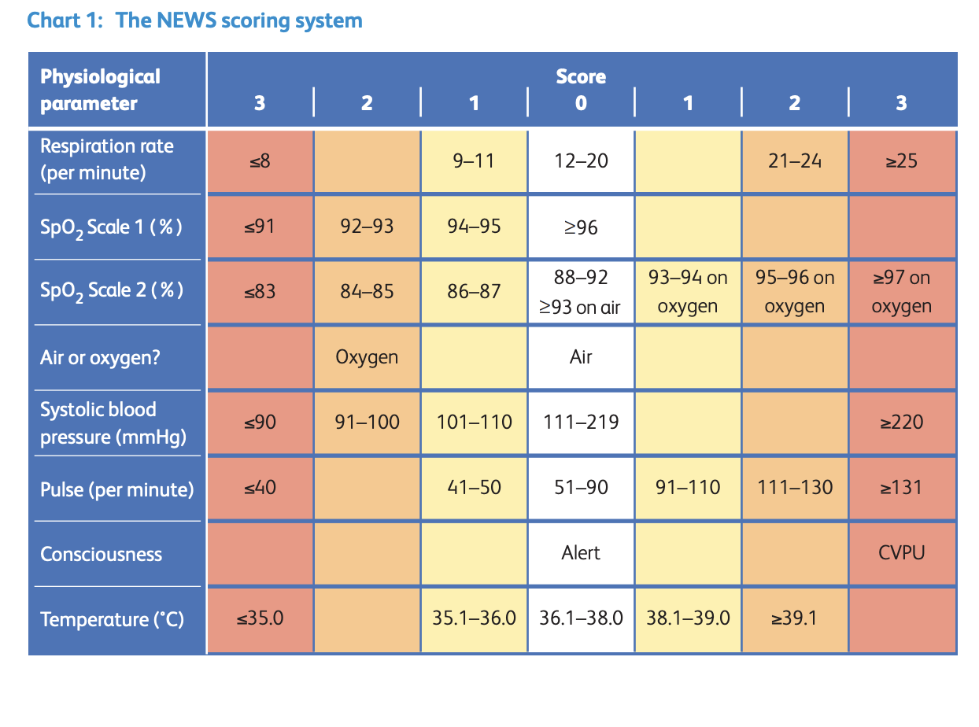

Figure 2 - Clinical Frailty scale

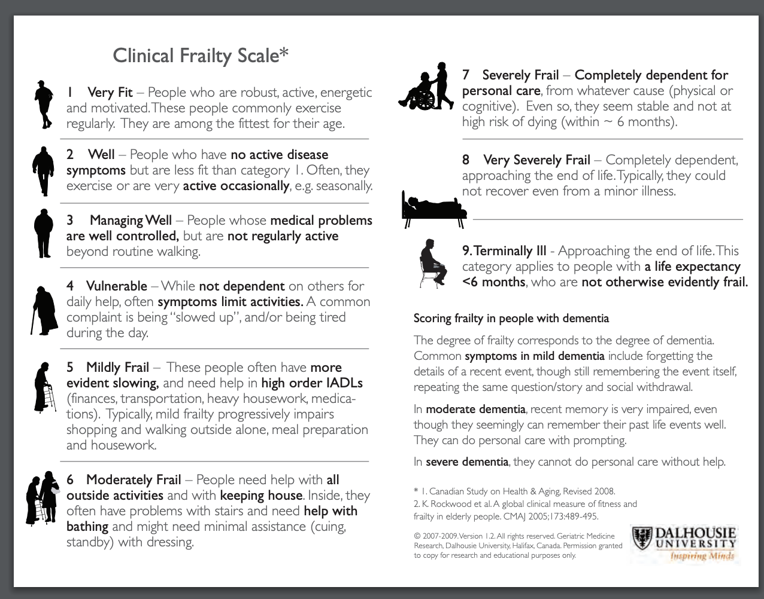

Appendix 2 Attributes of primary care treatment centres

The table below summarises the recommended attributes of primary care treatment centres

Arrival | Waiting area | Clinical area | Staffing | Estate, facilities & equipment
Access to site by private vehicle or walking only * | Capacity of waiting area based on social distancing guidance | Wash basin and hand sanitisation | Recommended shifts max 4 hours two shifts per week | IT required for urgent care provision including printers
Car park | Hand sanitisation and masks | Clinical facilities meet guidelines and requirements for the provision of urgent care services including infection control requirements | PPE available as per guidance | Site must be secure
Intercom available so reception can talk to patient without opening door | Area meets infection control requirements | Changing and shower area for removing PPE/decontamination | Core operating hours between 10am and 6pm | Cleaning arrangements in place in accordance with guidance for urgent care facilities
Locked reception to only receive one patient & carer at a time patients waiting outside advised of social distancing by clear signage | Specified toilet | Whole area able to be decontaminated (wipe clean surfaces and floor) | Current indicative capacity to assess and treat between 120 to 150 new patients per day per 60,000 population at peak | Secure and safe storage for medicines and equipment
Reception leads to designated waiting area | Area able to be decontaminated - all surfaces and floors | Secure sluice type cleaning facilities and storage for cleaning materials | Separate changing area able to be decontaminated after each use | Safe storage for staff member’s personal effects
No screening or triage facilities | Opening windows | Dedicated waste disposal facilities for all clinical waste including PPE | Separate toilet | Equipment and facilities required to provide urgent care for patients that are likely to be referred to the site. A list of likely equipment will be developed.
Isolation area for patients that present as very unwell | Isolation area for patients that present as or become very unwell | Opening windows | Staff rest area (staff will need to remove PPE to enter the rest area) | Access to laboratory services
 |  |  | Separate entrance and exit to building

*arrangements for staff that cannot access the site will need to be made

Appendix 3 (V3. 10.04.20)
Infection Prevention and Control Guidance (Facilities for face to face consultations with patients)

Summary of changes:

Revision date | Page number | Section | Change
07/04/20 | 3 | Hand hygiene | Embedded posters for hand hygiene technique for hand rub and hand wash
07/04/20 | 4 | Personal Protective equipment | Updated rationale for revision of this guidance
07/04/20 | 4 | Personal Protective equipment | Updated link to national guidance
07/04/20 | 5 | Choice of PPE | Revised table to indicate primary care treatment centre requirements
07/04/20 | 6 | Choice of PPE | Added definitions of home shielding, risk assessment, sessional use and single patient use
07/04/20 | 6 | Choice of PPE | Added table for general practice site choices and home visit choices
07/04/20 | 7 | Disposable gloves | Added guidance and diagram on safe removal of disposable gloves
07/04/20 | 9 | Filtering face piece | Added guidance on performing a seal check
07/04/20 | 10 | Environmental cleaning | Added guidance on daily cleaning and advice on deep cleaning when environment no longer needed as a primary care treatment centre
10/04/20 | 5 | Choice of PPE | Revised ‘primary care treatment centre’ table to indicate disposable plastic apron as the appropriate choice. Long sleeved gowns or coveralls to be used for Aerosol Generating Procedures only.
10/04/20 | 6 | Choice of PPE | Revised ‘home visit’ table to indicate disposable plastic apron as the appropriate choice rather than long sleeved gown for non-Aerosol Generating Procedures.
10/04/20 | 6 | Choice of PPE | Added column for Aerosol Generating Procedures to ‘home visit’ table
10/04/20 | 7 | Disposable Long Sleeved Gowns / Coveralls | Embedded posters for the donning and doffing of coveralls
10/04/20 | 11 | References | Added link and reference for revised national PPE guidelines for Primary Care

General principles summary:
The aim of this guidance is to ensure the facilities meet minimum requirements to ensure the safety of patients and staff are maintained.
- Indoor environments - walls, floors and surfaces of a smooth and impervious nature to facilitate cleaning and disinfection. All extraneous items to be removed
- Outdoor (drive through) environments – enable staff to clean hands and change PPE between each patient
- Waste that is generated needs to be disposed in foot operated lidded bins and in an area to reduce risk of wind / outside environment issues
- Bulk Waste wheelie bin needs to be lockable and secured
- Hand hygiene facilities need to be available to enable staff to wash with soap and water periodically especially at the end of the working day
- Staff changing facilities to enable donning and doffing of PPE and to change out of work clothes/uniform at the end of the day. To enable secure storage of staff clothing and items and to enable changing of gloves and aprons between each patient
- Consultation room for vulnerable or intimate patient assessments facilitate privacy, dignity and meet cleaning requirements
- PPE storage in an area to reduce the risk of environmental contamination and reduce the risk of theft
- PPE usage – as recommended in the guidance below. NB: gloves and aprons MUST be changed between each patient and hands cleaned
- Cleaning process and equipment all staff undertaking cleaning processes to be trained in cleaning infectious areas and equipment can be stored in a separate, dedicated area
- Clinical assessment equipment – to be of a cleanable material and cleaned between each patient usage

Facilities/ Environment
Indoor Facilities should have:
A separate waiting area, there should be no extraneous equipment such as magazines in the waiting area. Chairs must be of a cleanable nature at positioned at least 2 meters apart. Ideally there will be windows to allow for natural ventilation and no carpet.
Patients should be advised to use alcohol hand sanitizer and put on a surgical face mask.
Consulting rooms with hand wash basin and opening windows (this would be to allow cleaning and ventilation in-between patient consultations). Patient equipment should be kept to a minimum to avoid contamination; curtains should be removed where this doesn’t impact on patient privacy, cleanable flooring rather than carpet.
All equipment including couches, chairs, privacy screens and desks should be of a wipeable nature for ease of cleaning
Separate staff and patient toilet, to avoid staff contamination, there should be liquid soap and hand towels available for use.
Sluice/ cleaning cupboard for cleaning equipment, and disposal of cleaning products, storage of excess waste
Staff area for making drinks and break, preferably with hand wash basin
Staff changing area, it is recommended to change out of uniform/clothing prior to leaving the building.
A separate exit would be preferable to assist with patient flow and physical distancing of patients and maintaining a ‘clean to dirty’ flow

Outdoor (drive through) facilities should:
Have facilities to enable staff to clean hands and change PPE between each patient
Clinical assessment equipment – i.e. stethoscope, pulse oximeter probe, thermometer, BP cuff to be of a cleanable material and cleaned between each patient usage
Facilities to enable equipment cleaning between each patient use to be available
Foot operated lidded waste bins. These should be sited in an area to reduce risk of wind / outside environment issues

Infection Control practices
Standard infection control precautions (SICPs) and transmission based precautions (TBPs) must be used when managing patients with suspected (from board respiratory symptoms) or confirmed COVID-19.

Standard infection control precautions are the basic measures to reduce the risks of transmission of infection from recognised and unrecognised sources, whereas transmission based precautions are additional infection control precautions required to halt transmission of infection, categorised by the route of infection.

Routes of transmission
In COVID-19 the routes of transmission are considered to be contact, droplet and airborne during aerosol generating procedures.

Contact precautions: used to prevent and control transmission via direct or indirectly from the immediate care environment, this includes surfaces and equipment that may have been touched or contaminated with respiratory droplets.
Droplet precautions: These are used to prevent and control infection over short distances from the respiratory tract of one person directly to another, via mucous membranes (eyes and nose)
Airborne precautions: Used to prevent and control infection transmission without necessarily having close contact via aerosols from a person’s respiratory tract to another’s mucosa.

Standard infection control precautions
Patient placements
As this area is dedicated to management of patients with symptoms of COVID-19, anyone who does not have these symptoms should be re-directed.
There must be a dedicated area for patients to wait to reduce risks to others including staff, on entry to the waiting area patients would be asked to put on surgical mask and advised to sanitise their hands. Distance should be achieved by placing chairs 2 meters apart.
All equipment to be kept to a minimum and be of a cleanable nature, but should include a foot operated bin for patients to dispose of tissues as needed.
It is recommended to display respiratory / cough hygiene guidance in this area.

Hand hygiene
This is essential in reducing the transmission of infection, the WHO 5 moments guide should be used and in addition it should be carried out prior to donning personal protective equipment (PPE) and at certain stages of removal of PPE, and following removal of PPE.

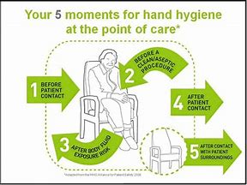

Soap and water is the preferred method of hand hygiene, however alcohol hand sanitizer are also effective against COVID-19.
Before performing hand hygiene:
- Expose forearms (bare below the elbows)
- Remove all jewellery (exception of a plain wedding band)
- Ensure nails are short and varnish free
- Covers cuts and abrasions
Technique should be good to include all areas of the hands, fingers and thumbs (see poster)

Personal Protective Equipment (PPE)

NB: The wearing of PPE does not take the place of hand hygiene and MUST be worn in conjunction with good hand hygiene practices.

REMEMBER: clean your hands after every episode of patient contact, after removing PPE and after handling waste and contaminated environments

This guidance has been updated to reflect the evolution of the pandemic and the changing level of risk of healthcare exposure. This revised guidance also reflects the need for enhanced protection of patients in vulnerable groups undergoing shielding.

https://www.gov.uk/government/publications/wuhan-novel-coronavirus-infection-prevention-and-control

For common contexts where health and social care workers are providing care to patients and individuals who are known to be possible or confirmed COVID-19 cases, PPE recommendations are specified. Attempts should be made, where appropriate, to ascertain whether a patient or individual meets the case definition for a possible or confirmed case of COVID-19 before the care episode.

One of the fundamental differences in the revised guidance is the use of certain items of PPE on a sessional basis rather than single patient use. Items identified for sessional use are those items that are worn for staff protection (i.e. masks and eye protection) and changing on a sessional basis reduces risks to healthcare workers from frequent changes of PPE.

Staff who have had and recovered from COVID-19 should continue to follow infection control precautions, including the PPE recommended in this document.
PPE should be donned prior to the patient being called in to the consulting area, and removed once the patient has left the consulting area.

Below are helpful video links to demonstrate both donning and doffing instructions for wearing PPE:

For performing non-aerosol generating procedures:

https://www.youtube.com/watch?v=-GncQ_ed-9w&feature=youtu.be

For performing Aerosol generating procedures:

https://www.youtube.com/watch?v=kKz_vNGsNhc&feature=youtu.be
https://www.youtube.com/watch?v=oUo5O1JmLH0&feature=youtu.be

Choice of personal protective equipment

Primary care treatment centres
NB: It is highly unlikely that aerosol generating procedures (AGPs) will be carried out at a primary care treatment centre
We appreciate that there are concerns about patients who desaturate during examination or travel to the primary care treatment centre and therefore possibility for a dedicated Covid-19 zone, within the primary care treatment centre needs to be considered to stabilise patients who will need high flow nasal oxygen (HFNO) i.e. with the use of a humidifier which is considered as an AGP. We will ensure to have the availability of FFP3 masks for these Covid-19 zones as per advice from PHE.

We aim to monitor the number of patients who need HFNO or high oxygen supply (i.e. not an AGP) and stabilisation to ensure that only appropriate category 2 patients are triaged to the primary care treatment centre and also monitor the risk to staff and ensure their safety is maintained.

 | Reception of primary care treatment centre, no physical contact | Entry to primary care treatment centre waiting area, no physical contact | Suspected COVID Patient consultation with examination i.e. listening to chest  (inc. home visit) | Nasopharyngeal or Throat swabbing suspected COVID patient | Aerosol generating procedures
Disposable gloves | Yes  * On a sessional basis | Yes  * On a sessional basis | Yes  ** Single patient use | Yes  ** Single patient use | Yes  ** Single patient use
*** Disposable plastic apron | No | No | Yes  ** Single patient use | Yes  ** Single patient use | No
Disposable long sleeved gown / Coveralls | No | No | No | No | Yes  * On a sessional basis  With single use plastic apron over the top
Fluid resistant (Type IIR) surgical mask (FRSM) | Yes  * On a sessional basis | Yes  * On a sessional basis | Yes  * On a sessional basis | Yes  * On a sessional basis | No
Filtering face piece (class 3) (FFP3) respirator | No | No | No | No | Yes  * On a sessional basis
Face shield or Disposable eye protection | No | No | Yes  * On a sessional basis | Yes  * On a sessional basis | Yes  * On a sessional basis

General practice sites

 | Reception of general practice site, no physical contact | Direct patient care/assessing an individual that is not currently a possible or confirmed case (within 2 metres)
Disposable gloves | No | Yes  ** Single patient use
Disposable plastic apron | No | Yes  ** Single patient use
Disposable long sleeved gown | No | No
Fluid resistant (Type IIR) surgical mask (FRSM) | Yes  * On a sessional basis  (only if within 2 metres) | Yes  * On a sessional basis
Filtering face piece (class 3) (FFP3) respirator | No | No
Face shield or Disposable eye protection | No | Yes

Home Visits

 | Direct patient care/assessing an individual that is not currently a suspected or confirmed case  (within 2 metres) | Direct care/assessing an individual who is suspected or confirmed as a case | Direct care or visit to any individuals in the extremely vulnerable group and where a member of the household is within the extremely vulnerable group undergoing shielding | Patients on HFNO or Aerosol generating procedures
Disposable gloves | Yes  ** Single patient use | Yes  ** Single patient use | Yes  ** Single patient use | Yes  ** Single patient use
Disposable plastic apron | Yes  ** Single patient use | Yes  ** Single patient use | Yes  ** Single patient use | No
Disposable long sleeved gown / Coveralls | No | No | No | Yes  ** single patient use
Fluid resistant (Type IIR) surgical mask (FRSM) | Yes  ** Single patient use or On a sessional basis | Yes  ** Single patient use | Yes  * On a sessional basis  (only if within 2 metres) | No
Filtering face piece (class 3) (FFP3) respirator | No | No | No | Yes  ** single patient use
Face shield or Disposable eye protection | Yes | Yes  ** Single patient use or On a sessional basis | No | Yes  ** single patient use

Definition of home shielding
Shielding is a measure to protect people who are clinically extremely vulnerable by minimising all interaction between those who are extremely vulnerable and others. People with serious underlying health conditions that put them at very high risk of severe illness i.e. from coronavirus (COVID-19), are advised to follow shielding measures in order to keep themselves safe.

* Definition of ‘on a sessional basis’
A single session refers to a period of time where a health care worker is undertaking duties in a specific care setting/exposure environment e.g. in a clinical assessment area. A session ends when the health care worker leaves the care setting/exposure environment i.e. for a break. Sessional use should always be risk assessed and considered where there are high rates of confirmed or suspected cases. PPE should be disposed of after each session or earlier if damaged, soiled, or uncomfortable. Items identified for sessional use are those items that are worn for staff protection and changing on a sessional basis reduces risks to healthcare workers from frequent changes of PPE.

** Definition of ‘Single patient use’
Single use refers to disposal of PPE or decontamination of reusable items e.g. eye protection or respirator, after each patient and/or following completion of a procedure, task, or session; dispose or decontaminate reusable items after each patient contact as per Standard Infection Control Precautions (SICPs). Items identified for single patient use are for both healthcare worker and patient safety to reduce the risk of cross infection.

Disposable long sleeved gowns / Coveralls
Disposable long sleeved gowns must be worn when a disposable plastic apron provides inadequate cover of staff uniform or clothes for the procedure/task being performed and when there is a risk of extensive splashing of blood and/or other body fluids e.g. during aerosol generating procedures (AGPs). If non fluid-resistant gowns are used, a disposable plastic apron should be worn underneath.

*** The choice of PPE is based on a place based risk assessment approach. Clinical assessment of patients in drive through facilities will be a lower risk and will not necessitate the need for wearing long sleeved gowns.

Disposable aprons
Disposable plastic aprons must be worn to protect staff uniform or clothes from contamination when providing direct patient care/ consultation and during environmental and equipment decontamination.
Disposable aprons and gowns must be changed between patients and immediately after completion of a procedure/task.
Fluid resistant gowns will only be required if you are carryout aerosol generating procedures or at risk from extensive splashing with blood and body fluids.

Disposable gloves
Disposable gloves must be worn when providing direct patient care/ consultation and when exposure to blood and/or other body fluids is anticipated/likely, including during equipment and environmental decontamination.
Gloves must be changed immediately, following the guidance on safe glove removal below, following the care episode or the task undertaken. Hands need to be cleaned after removal of gloves.

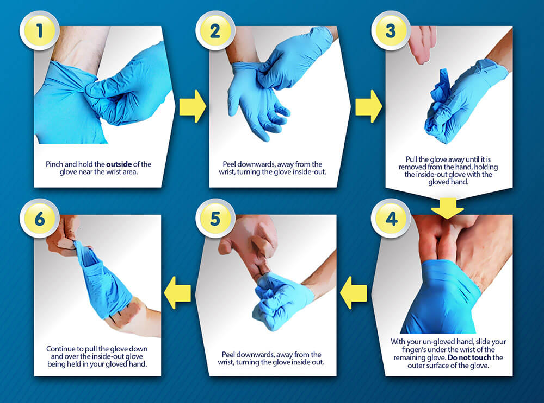

Eye protection / face visor
Eye/face protection should be worn when there is a risk of contamination to the eyes from splashing of secretions (including respiratory secretions), blood, body fluids or excretions. An individual risk assessment should be carried out prior to/at the time of providing care.
Disposable, single-use, eye/face protection is recommended.
Eye/face protection can be achieved by the use of any one of the following:
- surgical mask with integrated visor;
- full face shield/visor;
- polycarbonate safety spectacles or equivalent;
NB: Regular corrective spectacles are not considered adequate eye protection

Fluid resistant surgical mask (FRSM)
A FRSM for COVID-19 should:
- be well fitted covering both nose and mouth;
- not be allowed to dangle around the neck of the wearer after or between each use;
- not be touched once put on;
- be changed when they become moist or damaged;
- be removed outside the patient room, cohort area or 1 metre away from the patient with possible/confirmed COVID-19; and
- be worn once and then discarded as healthcare (clinical) waste (hand hygiene must always be performed after disposal).

Filtering Face Piece (class 3) (FFP3)
Filtering face piece (class 3) (FFP3) respirators should be worn whenever there is a risk of airborne transmission of pandemic COVID-19 i.e. during aerosol generating procedures.
NB: It is highly unlikely that aerosol generating procedures will be carried out at a primary care treatment centre.
Guidance on when to use a surgical mask and FFP3 mask can be found in the PDF file below.
All tight fitting respiratory protective equipment (RPE) (i.e. FFP3 respirators) must be:
- single use (disposable) and fluid-resistant*. Fluid resistant FFP3’s should be worn with appropriate eye protection;
- fit tested on all healthcare staff who may be required to wear an FFP3 respirator to ensure an adequate seal/fit according to the manufacturers’ guidance; fit checked (according to the manufacturers’ guidance) every time an FFP3 respirator is donned to ensure an adequate seal has been achieved;
NB: Whilst we are planning the roll out of fit test training to staff that need it, in the event that you carry out an aerosol generating procedure and need to wear an FFP3 mask, please ensure you follow the attached guidance on how to check that you have achieved a good seal

- compatible with other facial protection used i.e. protective eyewear so that this does not interfere with the seal of the respiratory protection. Regular corrective spectacles are not considered adequate eye protection;
- disposed of and replaced if breathing becomes difficult, the respirator is damaged or distorted, the respirator becomes obviously contaminated by respiratory secretions or other body fluids, or if a proper face fit cannot be maintained; and
- be worn once and then discarded as healthcare (clinical) waste (hand hygiene must always be performed after disposal). *If wearing a FFP3 that is not fluid resistant, a full face shield/ visor must be worn A FFP3 respirator, although ‘single use’, can be worn for as long as comfortable, for example for the duration of a ward round or providing clinical care. Once separated from the face FFP3s must be discarded.

Staff clothing
Appropriate use of PPE help will protect staff uniform from contamination in most circumstances, hence staff should change out of their uniform/ clothing and transport these home for washing in a plastic bag.
Uniforms/work clothing should be laundered:
- separately from other household linen;
- in a load not more than half the machine capacity;
- at the maximum temperature the fabric can tolerate, then ironed or tumbled-dried where possible.
NB: It is recommended that staff wear clothes that can withstand laundering processes at 60⁰C

Waste
All waste should be considered potentially infectious and disposed of in the orange bag waste stream, waste should be tied and stored safely prior to collection each day.
If it is not collected daily it must be stored in a dedicated locked waste compound.

Environmental Cleaning

Cleaning should be carried out once the patient has left the consulting room all touch surfaces such as chairs, desks, couches and all patient equipment used are to be wiped down using the guidance below, once this process has been completed, the room can be used immediately.

Communal areas, such as the waiting room, should be cleaned daily but any touch points in communal areas to be cleaned every few hours as this will be the highest risk.

The method below will also be effective on any blood and body fluid spillages.

How to clean
- Use disposable cloths or paper roll and disposable mop heads
- Disinfectant wipes such as Clinell Universal Wipes are effective against Coronavirus within 60 seconds.
- Clean and disinfect all hard surfaces, floor, chairs, door handles and reusable non-invasive equipment or sanitary fittings in the room
- A mixed detergent/ disinfectant such as actichlor or chlor-clean may be used to clean/disinfect as per manufacturers guidance
- A neutral purpose detergent (washing liquid) followed by disinfection (1000 ppm av.cl.) which can be domestic/household bleach if you do not have the above solution
- In practical terms, household bleach mixed with water, is an inexpensive and effective disinfectant. Using a standard detergent to clean e.g. washing up liquid followed by a household bleach dilution of 20ml bleach to 1000ml water or 100ml household bleach to 5000 ml water will give 1000ppm av.cl.

Important
- A bleach and water solution should be mixed daily to preserve its strength
- Leave the solution on the surface for a minimum of one minute
- Cleaning must be done prior to disinfecting any cloths and mop heads used must be disposed of as single use items

All areas should have a full clean at the end of each day using the guidance above. This is not a ‘deep’ clean, which is a very different process, but is a standard clean.

A full deep clean will need to be undertaken prior to the area and equipment returning to business as usual

References:
- Guidance on infection prevention and control for COVID-19. PHE 27th March 2020; updated 2nd April 2020
- Advice for primary care professionals dealing with patients with suspected COVID-19. PHE 19th March 2020
- Recommended PPE for primary, outpatient and community care by setting, NHS and independent sector (table 2). PHE 2nd April 2020. https://assets.publishing.service.gov.uk/government/uploads/system/uploads/attachment_data/file/878750/T2_poster_Recommended_PPE_for_primary__outpatient__community_and_social_care_by_setting.pdf

