Protocol for new patients with online access codes
Four concepts to find patients with any of the ‘own health record’ codes and of those, patients where the latest code is declined, withheld or review required.
The five codes are:
1290331000000103 Online access to own health record declined by patient
1364731000000104 Enhanced review indicated before granting access to own health record
1364751000000106 Enhanced review not indicated before granting access to own health record
1290311000000106 Online access to own health record granted following enhanced health record review
1290301000000109 Online access to own health record withheld following enhanced health record review

Any ‘own health record’ codes protocol:
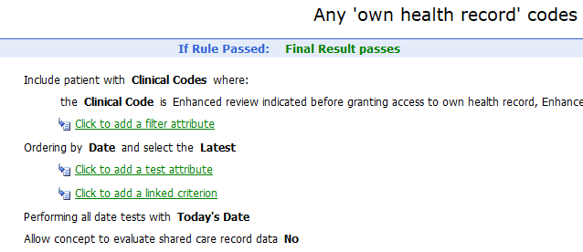

Example of ‘latest code’ protocol - Latest code is declined:
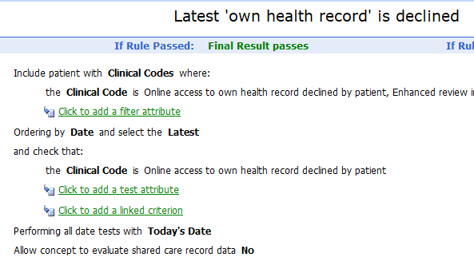

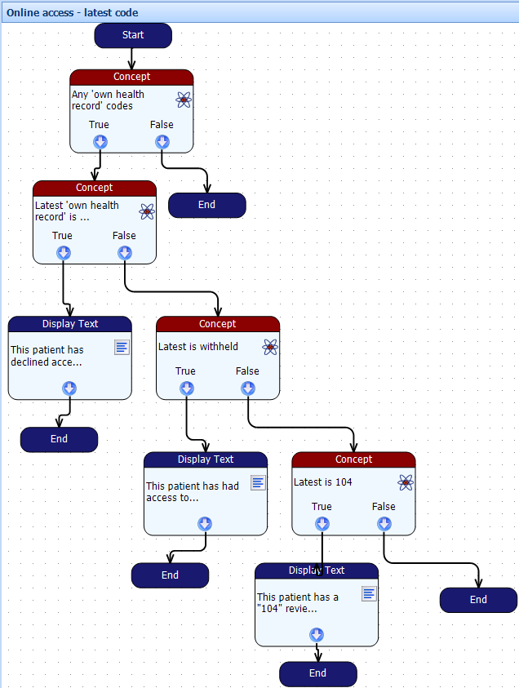
If ‘review required’ is latest,
display a screen message.
If not,
no further action required (End).
If ‘withheld’ is latest,
display a screen message.
If not, is the latest one
‘review required’?
If ‘declined’ is latest, display a screen message.
If not, is the latest one ‘withheld’?
If any of the five codes exist, is the latest one ‘declined’?
If none found, no action required (End).

Protocol looks for any of the five codes.

Set Trigger on Register Patient (Regular)

