Online access reports
“Online access status” will show which of your regular registered patients have an online account
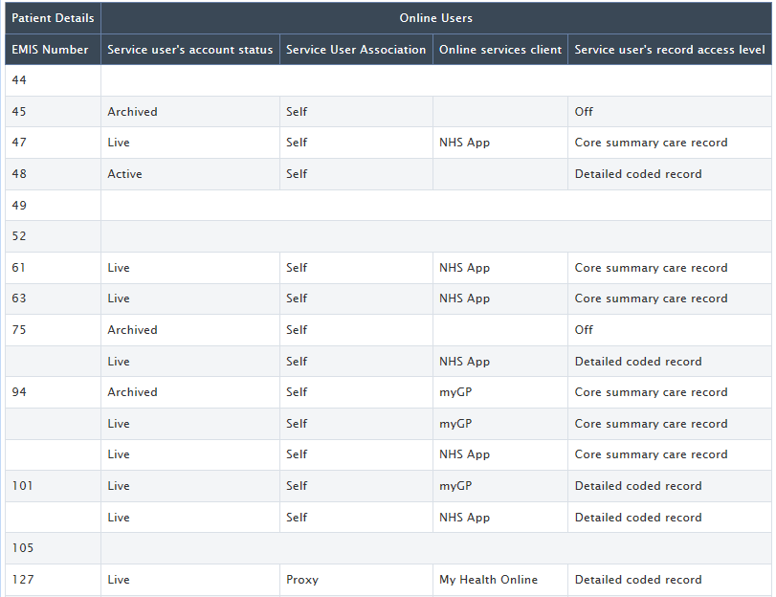
We have included only EMIS Number in the Patient Details table (which is sufficient to identify any patient that you wish to look at further), but you could add more columns (e.g. name) if you wish.
The Online Users table has four columns, with the following options
Service User’s account status:
Live = in use
Active = set up but not in use
Archived = not used for over 12 months
blank = no online access
Service User Association:
Self = patient has access to their own record
Proxy = someone else has access to the patient’s record
Online services client:
The service providers with whom the patient has an account (they may have several)
Service User’s record access level:
Off = no access to coded data
Core = meds & allergies only
Detailed = some/all of the available sections, will likely be different for each patient
If you wish to add criteria to the report, see the next two pages

You may wish to amend the “Online access status” report, to remove the patients who do not have an online account, for example.

Edit the report and select the Criteria link in the Online Users table:
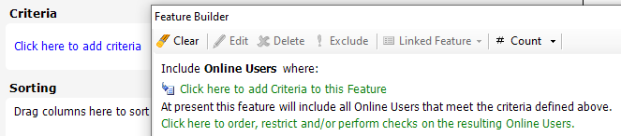

These are the options available for each of the columns included in this report:
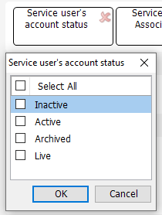
Service user’s account status:
Live = in use
Active = available, but patient needs to link account to practice
Inactive = ID verification required
Archive = inactive for 12 months or more

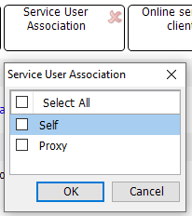
Service User Association:
Self = patient has access to their own record
Proxy = someone other than the patient
has access to the patient’s record
(instead of or as well as the patient having Self access)
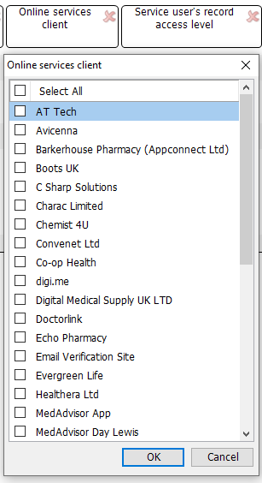
Online services client:
A list of the available providers
The report will show all the providers with whom the patient has an account if none are selected.
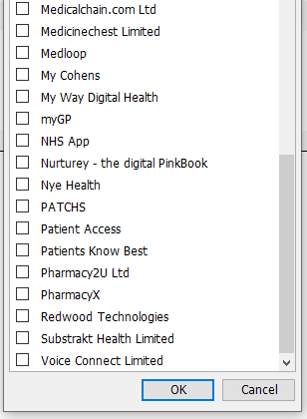
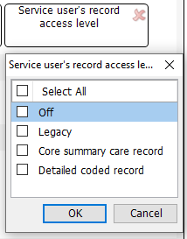
Service user’s record access level:
Off = no access to coded data
Core summary care record = Meds and Allergies only
Detailed coded record = some/all coded data
(and none/some/all free text)
Legacy = previous settings
(this option is unlikely to exist in most practice systems now)

The “Online access level” report will show how much data each regular registered patient can see
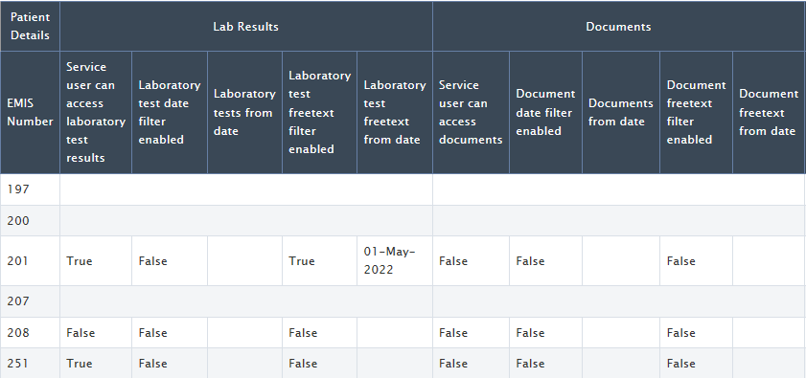
This is a small portion of the full report – you will need to Export to CSV to view and manipulate the full data.
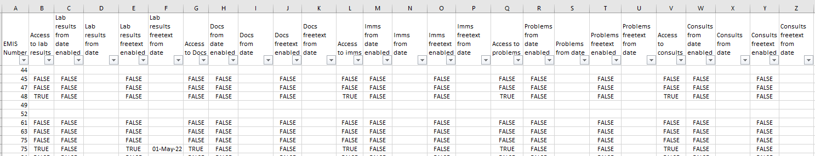
[we have amended the column header text to allow the screenshot to fit!]
The following is an example, but the principle is true for the five columns in each section:
Lab Results columns B-F
Documents columns G-K
Immunisations columns L-P
Problems columns Q-U
Consultations columns V-Z
Consultations:
Filter column V (“Service user has access to Consultations”) by TRUE only
Column W (“Consultations from date enabled”)
FALSE = patient has access to coded data in all their consultations
TRUE = patient has access to coded data in consultations from
the date shown in column X (“Consultations from date”)
Column Y (“Consultations freetext filter enabled”)
FALSE = patient cannot see free text within any consultation
TRUE = patient can see free text within consultations from
the date shown in column Z (“Consultations freetext from date”)

