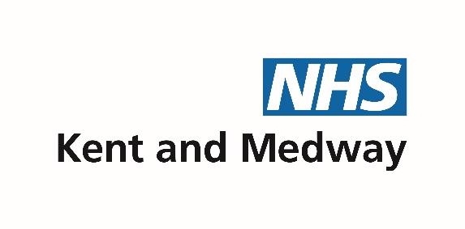

Improving Hypertension Treatment Rates in Kent and Medway

I am writing to you to draw your attention to an important issue in our region. As you may be aware, Kent and Medway have the lowest treatment to target rate for patients with known hypertension in the country. This means that many patients are not receiving the appropriate treatment, which can have serious implications for the patient as well our health and care systems.

In order to improve, we need to work together as a system to identify and address the root causes of this issue and work is ongoing to do this. In the meantime, the end of the QOF year is only 4weeks away, so we were keen to try and provide some short-term help to practices and evaluate future ways we could address this need.

We are pleased to announce that Accurx has agreed to a free one-month pilot, ending on March 31st, 2023, where they will give access to Florey Plus (including the Blood Pressure and 7 Day Blood Pressure) and Batch messaging for every practice across Kent and Medway. The Integrated Care Board (ICB) has agreed to pay for the cost of the texts (SMS fragments) to support this initiative.

To note:
- This is a pilot until 31 March 2023, and we will evaluate the outcomes thereafter and make recommendations to the Executive Team for future scalability.
- You will have full access to batch messaging module, but we ask that you only use this for the purposes of Hypertension only. The ICB has covered the cost of the extra SMS fragments until 31 March 2023.

As well as the Digital PLTs currently running, we will be providing additional information and training sessions to help you make the most of these resources. Here are some resources in the meantime:

- General introductory guide to Floreys here
- SNOMED Codes and Questions for single reading BP questionnaire here
- SNOMED Codes and Questions for 7-day questionnaire here
- Youtube Video of Webinar which runs through how to send Floreys via Batch is here

For those that don’t have access to home BP machines some options you might consider:
- Working with community pharmacy
- Setting up a drop-in in your waiting rooms or a PCN based offering out in the community for harder to reach communities
- Mobilising your COVID volunteers or your PCN based care co-ordinators and health and wellbeing coaches.

Thank you for your support. Let’s show everyone what General Practice in K&M is capable of.

Dr Krishan Bhanot
CVD Prevent & Digital Clinical Lead | K&M ICB

--

