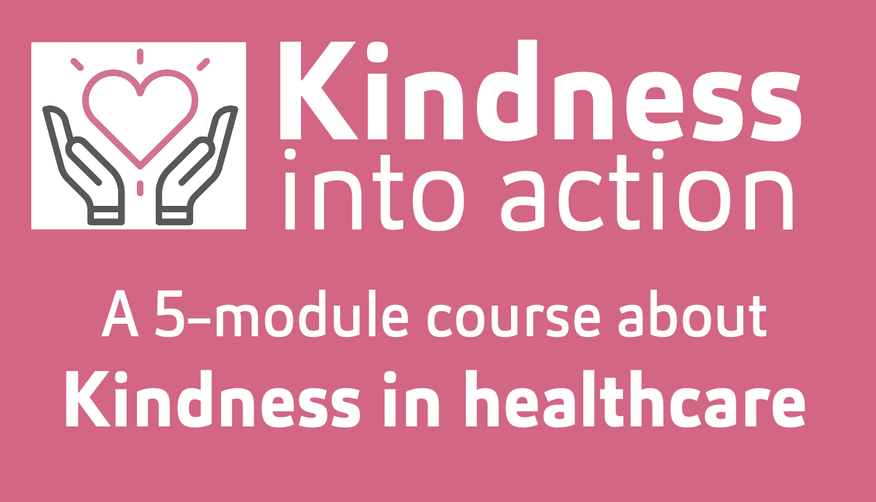

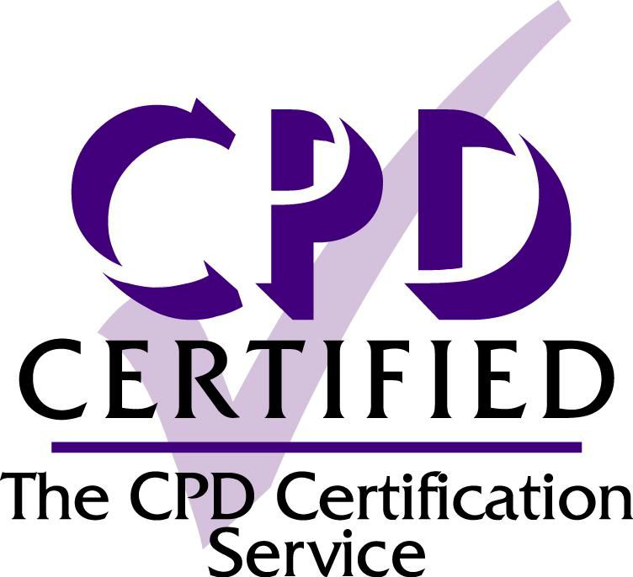
Kinder healthcare is safer, higher-quality healthcare. Kindness into
Action is an evidence-based online course, bringing to life the impact
of respect, kindness, positivity and incivility in healthcare. The five short
Kindness into Action modules provide bite-sized access to practical
tools and strategies that you can start using right away in your practice.
Full course duration: Approx. 3.20 hours

Module 1: Kindness into Action - setting the scene
Module duration: Approx. 10 min
Module description: This module lays the foundation for the Kindness into Action course and introduces you to some of the evidence that describes why kindness is essential for colleagues and for patients.
A brief tour thorough the evidence for kindness, and against incivility, in healthcare.
Module objectives:
- Share ‘the case for kindness’, the evidence that describes why it is essential
- Introduce you to the 3 things that make a good day at work
- Give you a taster of what to expect in the modules that follow

Module 2: Kindness into Action – cultivating kindness
Module duration: Approx. 50 min
Module description: It’s not just good to be kinder, in this module we will look at the evidence showing that kinder healthcare is higher quality healthcare.
For each source of evidence, we will dig into what that means and explore specific ways of bringing kindness into your work to reap these benefits.
Module objectives:
- What being kind means at work
- Discover how your strengths can help you enjoy work more
- Learn the 3 things you can do to make more good days for others

Module 3: Kindness into Action – undoing unkindness
Module duration: Approx. 40 min
Module description: In this module you’ll learn how unkindness, from uncivil behaviour to banter, to bullying, impacts on the safety and wellbeing of staff and patients. The good news is we can do something about it…
Module objectives:
- Discover the surprising benefit of more kind and positive interactions
- Understand what unkindness looks like in healthcare, and how you might recognise this in your day-to-day work

Module 4: Kindness into Action – kinder feedback loops
Module duration: Approx. 45 min
Module description: To feel safe to speak up we need to know how to speak up. In this module, we introduce you to intentional praise to amplify kind behaviours and BUILD kinder feedback to speak up when you need to.
Module objectives:
- Learn the foundations of great feedback
- Explore 2 simple models to support you in amplifying positive behaviours and calling out unhelpful ones
- See how to use feedback to develop better relationships

Module 5: Kindness into Action – RECOVER, a positive summary
Module duration: Approx. 55 min
Module description: Now that you’ve explored the previous modules, you can bring it all together with the RECOVER framework, a simple model to encourage kindness and support wellbeing in your team.
Module objectives:
- Learn the 7 key wellbeing conversations to have with your colleagues and team
- Equip you with practical tips you can use to enhance your own wellbeing right away
- Consolidate your learning from the previous modules so that you feel confident to use the strategies you’ve explored
- Download your CPD certificate for ½ day’s learning

